You Have the Idea, What’s Next?
How to Plan and Execute your Adoption Event

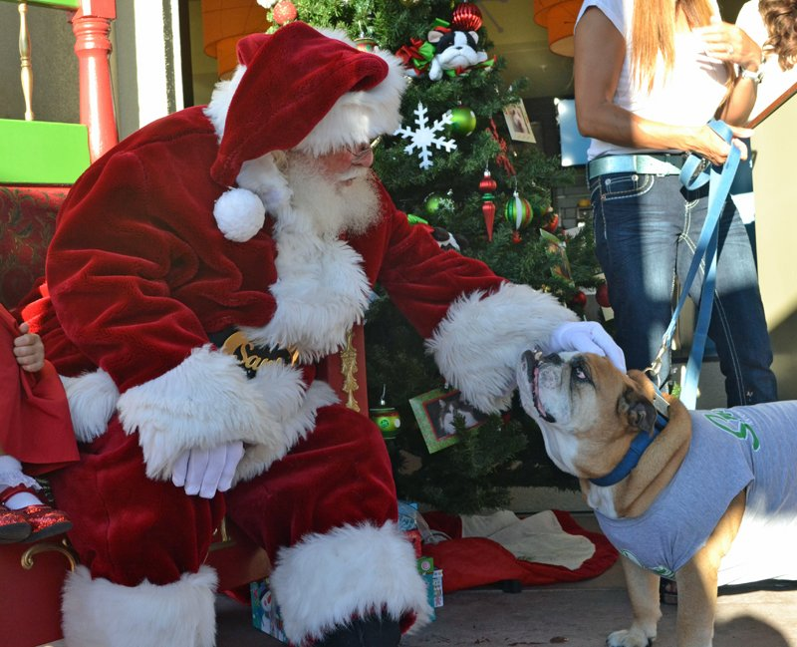

- Determine the date, time and location of your event
- Date – Make sure the date coincides with the Home 4 the Holidays campaign (October 1, 2024 to January 5, 2025). Check local calendars to be sure that no other major media event is planned for your ideal date.
- Time – Select the time that you can get the maximum number of attendees, staff and volunteers and the time that works best for the media. (TIP: Morning events are ideal for broadcast media since the footage they shoot can be edited in time for midday and evening news broadcasts.)
- Staff – Make sure that you select a date and time that allows you to have plenty of assistance with your event. Once you have cemented your event on the calendar, make sure that everyone – staff, volunteers, board members – has the event marked on their calendars too.
- Location – If you have the proper space for an event at your facility, it is ideal. Having your event where you do your adoptions will familiarize the public and the media with your location. If you do not have a facility, arrange to have an off-site event. Research vacant spaces (such as empty retail locations in local malls, church parking lots or neighborhood parks) and request the donation of space for the day of your event.
- Communicate – Get the word out to all members of your organization so that they can plan on attending and/or inviting others. Email is a great way to communicate event specifics as well as posting flyers or bulletins throughout your organization.

2. Contact local dignitaries
Contact your mayor, city council member, etc. – and request that they make an appearance at your event to issue a proclamation for “Home 4 the Holidays Day.”
(Samples for a proclamation request and proclamation template can be found in the “Template Materials” section of the How-To Guide.)
- A local politician or celebrity’s endorsement of the campaign at your shelter can help attract public and media attention.

3. Design all print materials needed to publicize your event
Prior to your event, you will want these materials available for visitors at your reception area, throughout your facility and at local businesses that support your organization. Don’t forget to create “day of” materials too! (For example, signage for the event and take-away pamphlets with more information about your facility.) Create your own or adjust the ones provided.
(Samples for Home 4 the Holidays flyers and posters can be found in the “Template Materials” section of the How-To Guide.)
- Event flyers
- Posters
- Day of signs and/or banners
- Flyers about your organization

4. Confirm your event specifics in writing
Confirm your event specifics with key staff members and/or dedicated volunteers helping to create your event, after determining what materials you will need.
- Consider whether you will need food, drinks, prizes, games, decorations, music, etc.
- Determine whether you can get any of your needed items donated.
- If your event includes a politician or celebrity, decide whether you will need a podium, microphone, etc.
- Decide how you will set up your event to maximize the possibility of pet adoptions. (Do you need a table and chairs for filling out adoption forms? Do you need a computer? etc.)
- Make sure you have a photographer scheduled, even a volunteer photographer, for the day of your event! You’ll want to share these photos with the media and on social media immediately after the event.

5. Prepare and distribute media materials
(Samples for a media pitch, press release and media alert can be found in the “Template Materials” section of the How-To Guide.)
- Develop a good list of media contacts by obtaining the email addresses of the news desks at all local TV stations; the morning show producers at all the local radio stations; and the editors of all the local papers, magazines and on-line news services.
- Be sure to get your pitches (a letter sent directly to a specific news anchor or radio host), press releases (a formal announcement of your event) and media alerts (an event reminder) out in plenty of time for media to get your event on their calendars.
(Media pitches should go out no later than 4-5 weeks in advance; Press releases should go out no later than 3-4 weeks in advance; Media alerts should go out no later than 2-3 days in advance.)
- Do NOT send out anything that doesn’t include a great visual! Take adorable photos of your pets to send along with your media communication. (Is your event Halloween-themed? Consider dressing some puppies in cute doggy costumes. Is your event Santa Paws-themed? Do you have a kitty that looks like he has a white beard? Be creative!)

6. Share the excitement!
Create a buzz about your event on social media and in all local press calendars. Newspapers, magazines and websites normally have event calendars available.
(A sample for calendar listings can be found in the “Template Materials” section of the How-To Guide.)
- Post your event flyer on your organization’s website, Facebook page and Twitter account.
- If you have a website blog, write about all the exciting preparations you are doing for the upcoming event.
- Use #IChosetoRescue to share adoption stories with us and the world!

7. Organize staff and volunteers
- Make sure everyone understands his/her role and has clear direction on his/her responsibilities.
- Hold meetings to keep the lines of communication open and obtain input.

8. Provide local officials and any other participants with an agenda
Be sure to outline details of timing and what you expect them to do at the event. (This agenda should go out no less than 1 week in advance. If you would like to have your local official say something specific, provide them with a script no later than 2-3 days in advance.)
- If you plan on having an organization spokesperson, or a celebrity host, speak at the event, be sure to create a one-sheet with a few points about the event and the Home 4 the Holidays campaign that you would like them to communicate. (As appropriate: Remind them that this event is strictly for the benefit of the animals. The goal is to build awareness for homeless pets, to encourage spaying/neutering and micro-chipping and to educate the public.)

9. Send out a media alert
Send a media alert two to three days before the event to make sure local media attend.
A media alert differs from a press release because it is more concise with the basic who, what, when and where of the event. It should also provide the media a list of good visuals for their cameras and a list of available guests and interview opportunities. A media alert should only be sent AFTER a more formal press release has gone out.
(A media alert sample can be found in the “Template Materials” section of the How-To Guide.)
- Be sure to send a list of all the great visuals they will be able to get on camera while they are there! (Puppies dressed in green and red bandanas; a local celebrity adopting a kitten; the mayor making a proclamation; a kid and puppy Halloween costume contest; etc.)
- Keep track of media who are interested and planning to attend your event so you can look for them and their stories following the event.

10. Follow up with the media
Remember to follow up immediately after the event. Even if the local media didn’t make it out to your event, they will often do a follow-up story if you send them some great photos from the day, good news adoption stats from the event and/or short clips of video footage (even brief but entertaining clips from a smartphone) from the festivities.
- Also make sure you send friendly thank you notes or emails to those who did attend your event!
- Share the same photos, video and good news adoption stats on your website and social media channels. Remember to use #IChoseToRescue!

